Logging into AR:

1st log onto: http://belaire.reedschools.org/site/default.aspx?PageID=11

Click on Accelerated Quizzes:

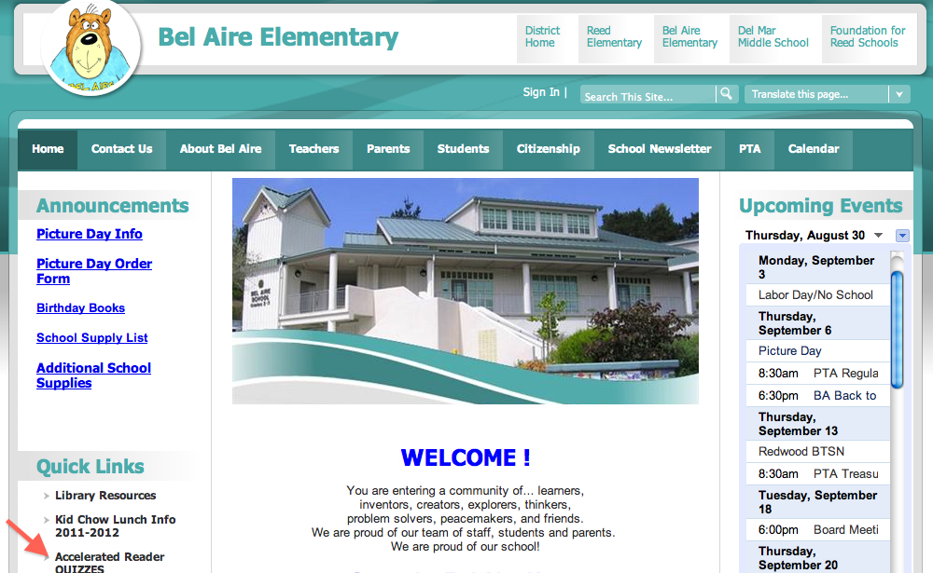

Now, click on Student, and enter Username and Password:

Next, Scroll down to STAR Reading, and Take a Test

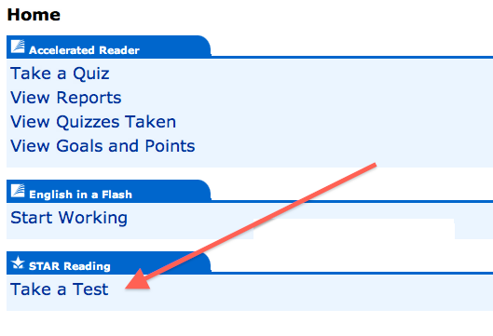
Press Start

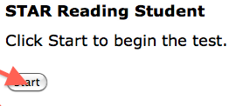

The password: books

Now, enjoy your reading

