How to delete a quiz for a kid:

Click on Record Books and Goals

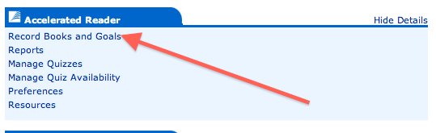

Now, click on Reading Practice Quizzes

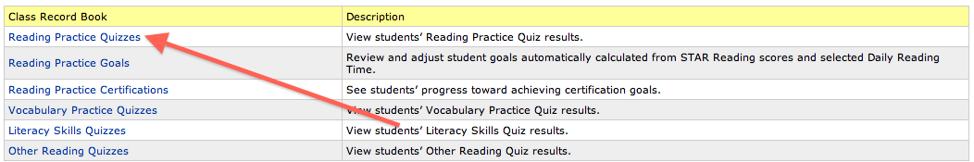

Next, scroll so your name appears, and then click on the kid.

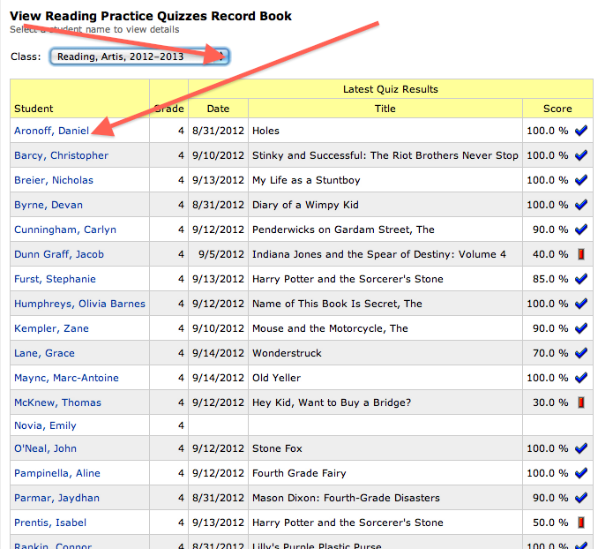

Now, select the quiz you want, and click “delete.”

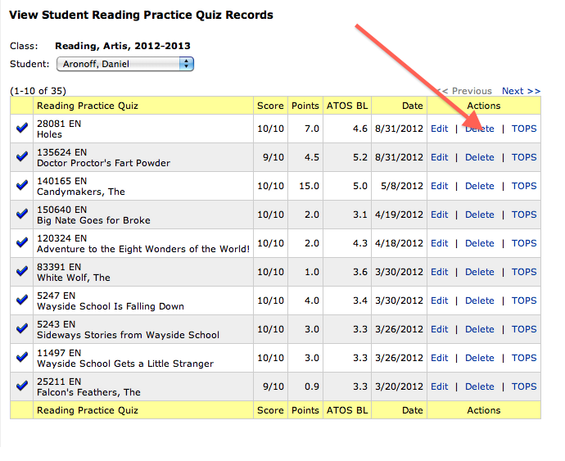

Poof! Done and Deleted

