First, log in.

Click on Record Books and Goals
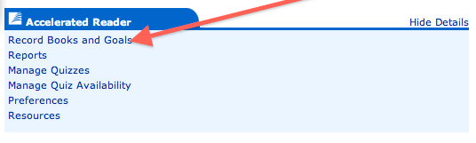
Click on Reading Practice Goals

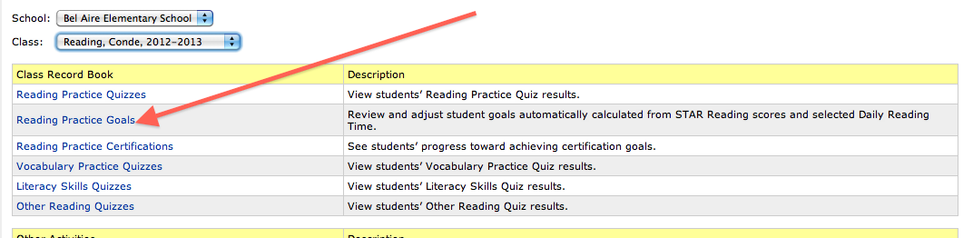

Select Marking Periods

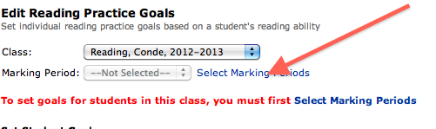

Select Trimester 1, then it will appear above, and press Save.

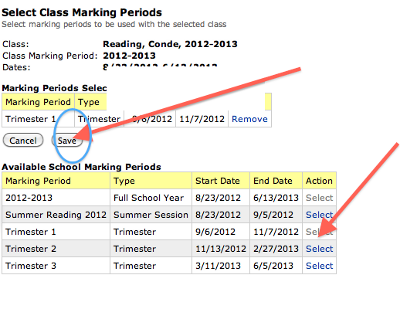

Now, write in goals, and press Save.
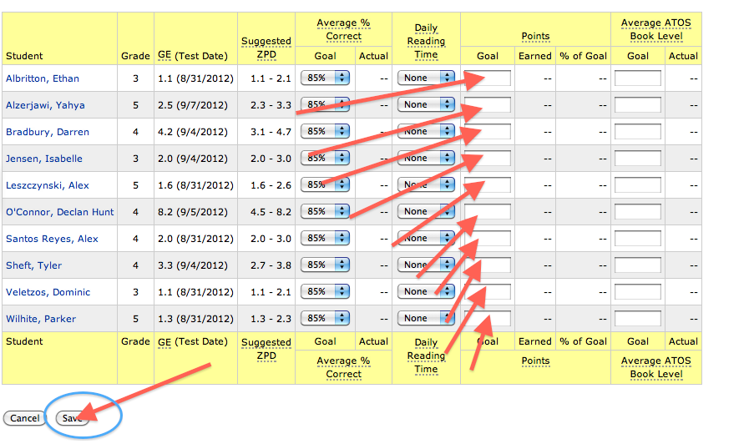

Enjoy Goal Setting

