If you student comes across this when trying to take a quiz, have them click on the red x in the top right corner.

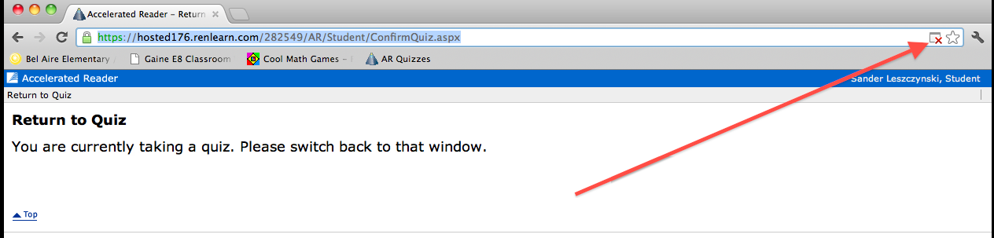

A closer look:

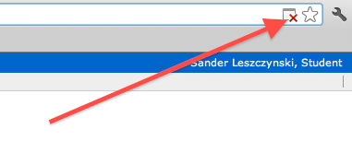

Now, you can allow pop-ups, and click on the quiz from this box:

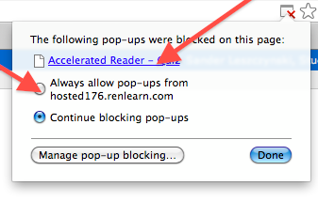
Enjoy Pop-Ups

