Log into AR:

1st log onto: http://belaire.reedschools.org/site/default.aspx?PageID=11

Click on Accelerated Quizzes: (Then bookmark it!)

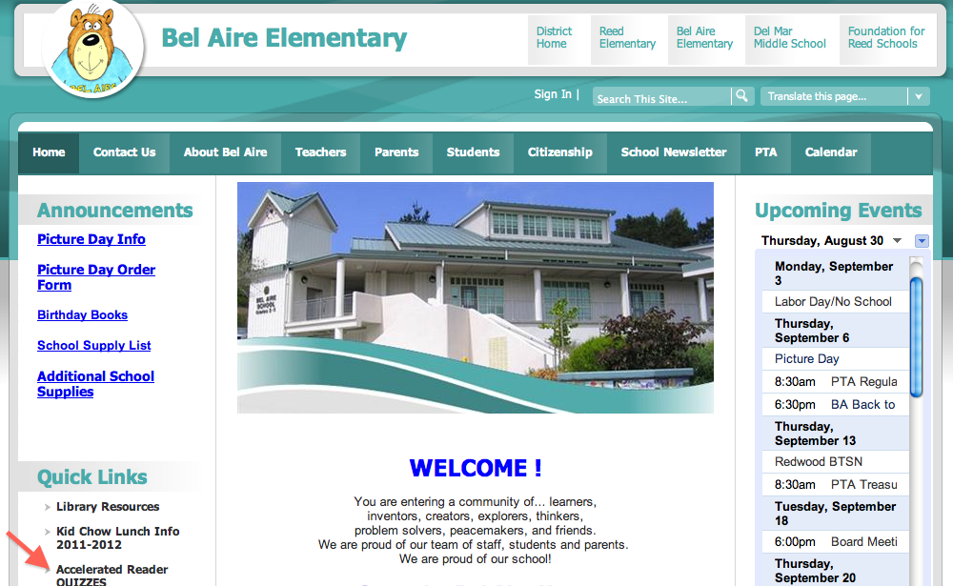

Now, click on Teacher, and enter Username and Password:

Next, Scroll down to STAR Reading, and Reports

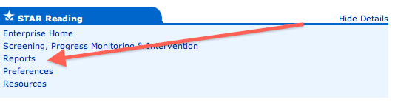

Click on Summary

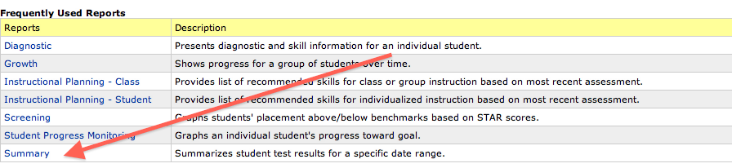

Click on View Report, and give NO concern to the preferences below the option.

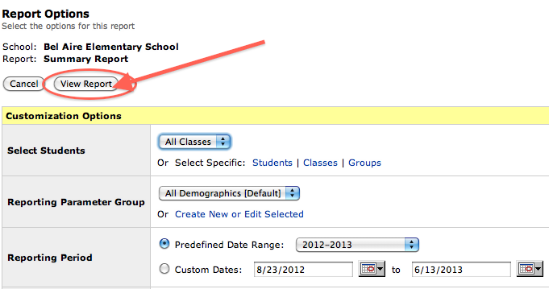

The report follows as a PDF: You can save it as whatever you’d like. Note: If new to Chrome, then the PDF doesn’t automatically pop out. See someone who knows on how to save it to your desktop, files, etc.

The red is the Independent Reading Level, and the blue is the range.

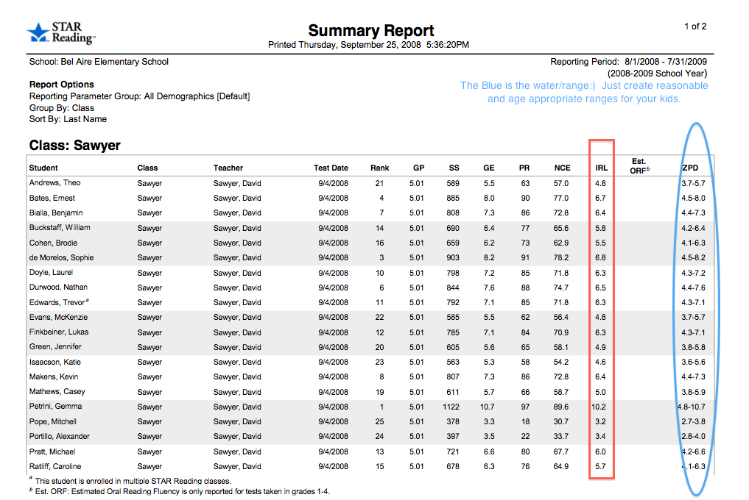

Happy Goal Setting

